**Employee table :**



**1. Display all the fields of employee table**

**2. Retrieve employee number and their salary**

**3. Display details of employee whose name is AMIT and salary greater than 50000;**

**4. Write a query to find the salary of the employee where branch is not Bangalore and salary >= 25000.**

**5. List out empno, emp_name, dept for all employees**

**6. List out empno,emp_name,dept for all employees and rename empno as “ID of the employee”, ename as “Name of the employee”, dept as “department ID”**

**7. List out the employee’s annual salary with their names only.**

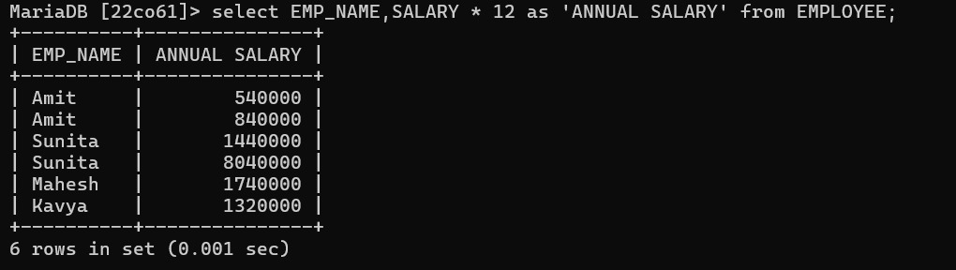

**8. List the details about Amit**

**9. List out the employees whose name starts with “S”**

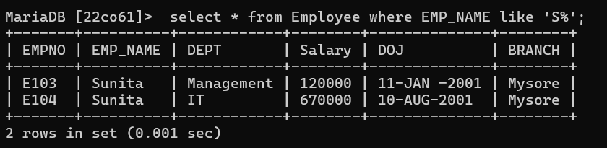

**10. List out the employees who are working in department IT**

**11. List out the employees who are earning salary between 30000 and 85000.**

**12. List out the employees who are working in department HR or IT or Civil.**

**13. Find out the employees who are not working in department HR or IT or Civil.**

**14. List out the employees who have no Branch assigned.**

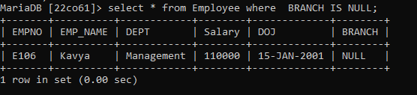

**15. List out the employees whose name start with ‘A’ and end with ‘T’**

**16. List out the employees whose name length is 4 and start with ‘A’**

**17. List out the employee names with ‘a’ as the second character.**

**18. To display empno and ename combined with a space in between.**

**

**20. Display name of employee in descending order**

**21. List out the empno, ename in ascending order based on the empno.**

**22. List out the empno, ename in descending order based on salary column.**

**23. List out the employee details according to their ename in ascending order and salaries in  descending order**

